Therabody SmartGoogles
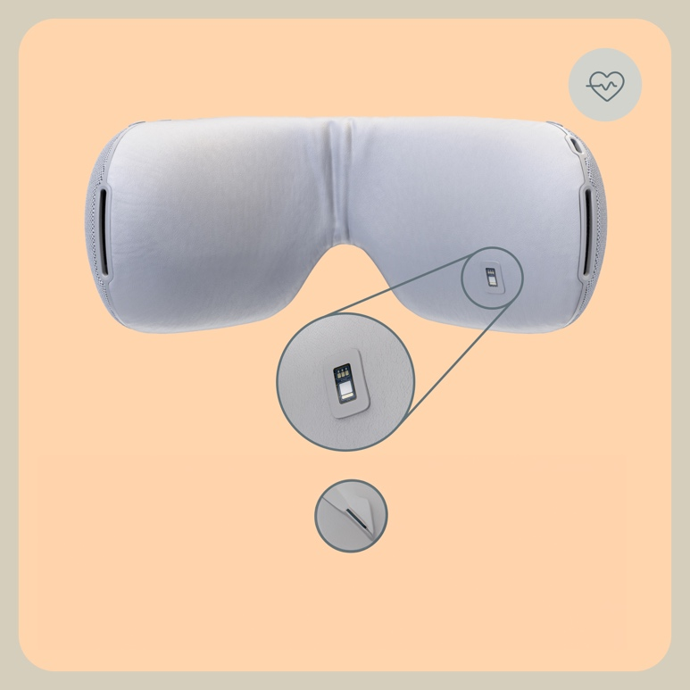

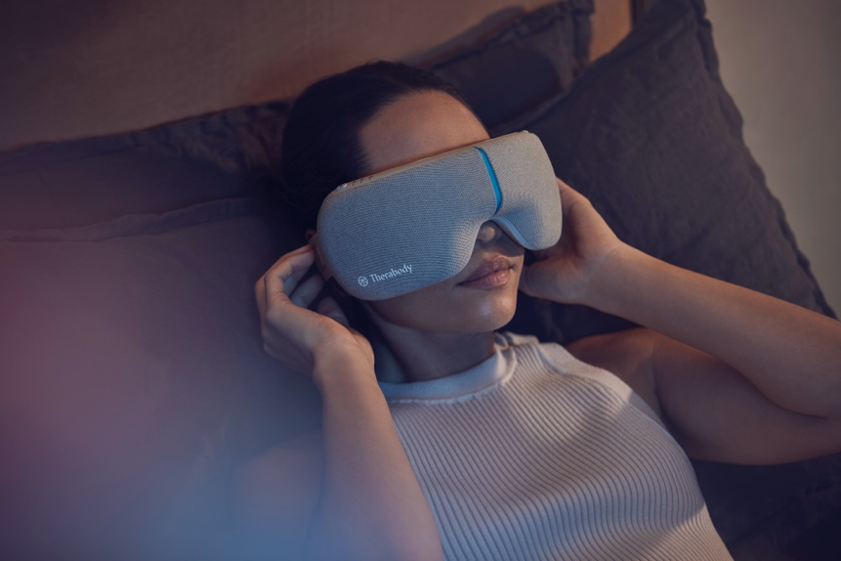
The only eye mask equipped with SmartSense Technology™
With an exclusive biometric sensor that adjusts treatments to lower your heart rate to a calmer state. Put it on to soothe headaches, relieve eyestrain, and induce calm into your body and mind. Whether you stare at a screen all day, suffer from headaches or anxiety, or can't fall asleep, SmartGoggles will keep you moving throughout the day and help you rest at night.

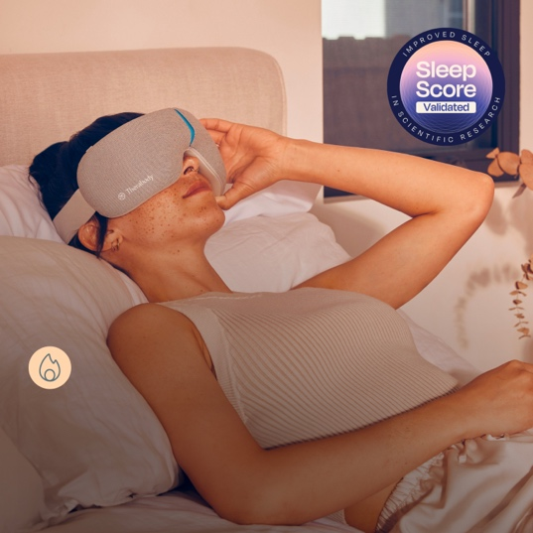

Reduction of stress and anxiety
SmartRelax mode provides personalized vibration patterns that lower your heart rate.

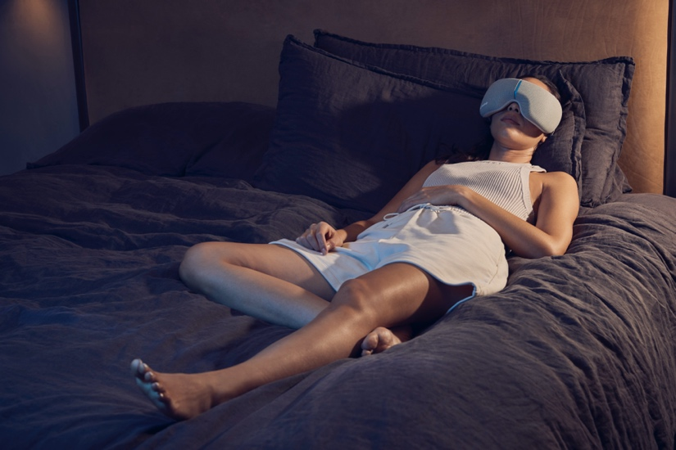

Relieves headaches and eye fatigue
Heat, massage and vibration work together to relieve eye strain and facial tension that is usually associated with headaches and migraines.

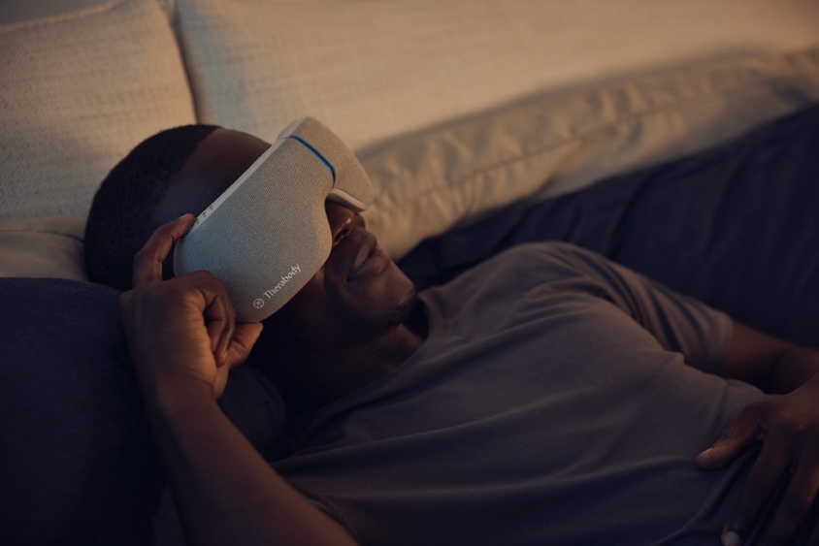

Improves sleep quality
Gentle temple massage delivers slow waves of vibration to lull you into a restful sleep.

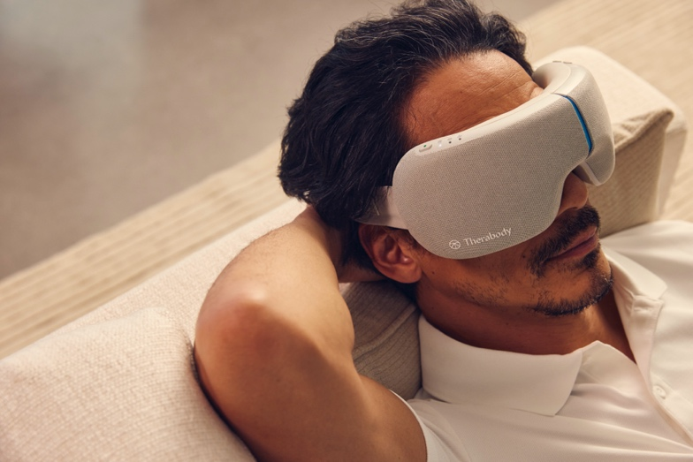

Synchronization of mind and body
Immerse yourself in a world of scientifically based soundtracks to help you stay focused, relax and fall asleep. Launched exclusively with SmartGoggles in the Therabody app.

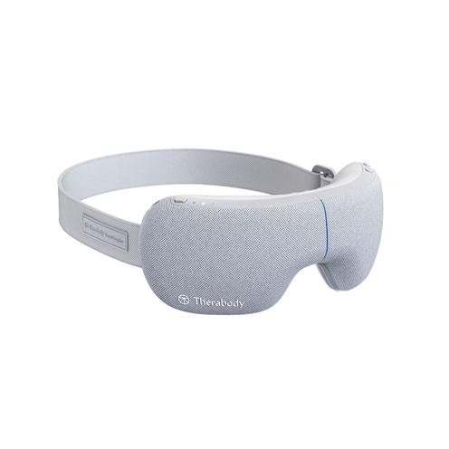
Key Features
- SmartSense™ technology powers SmartRelax mode, which physically lowers heart rate and helps reduce stress and anxiety.
- Multiple modes: vibration, massage and heat
- 3 customizable modes: Focus, SmartRelax and Sleep
- Portable, foldable design for relaxation anywhere on the go
- Compatible with Bluetooth and TheraMind technology - in-device multisensory sound therapy
- Therabody app, exclusive to the use of SmartGoggles
- Battery life of 150 minutes depending on mode

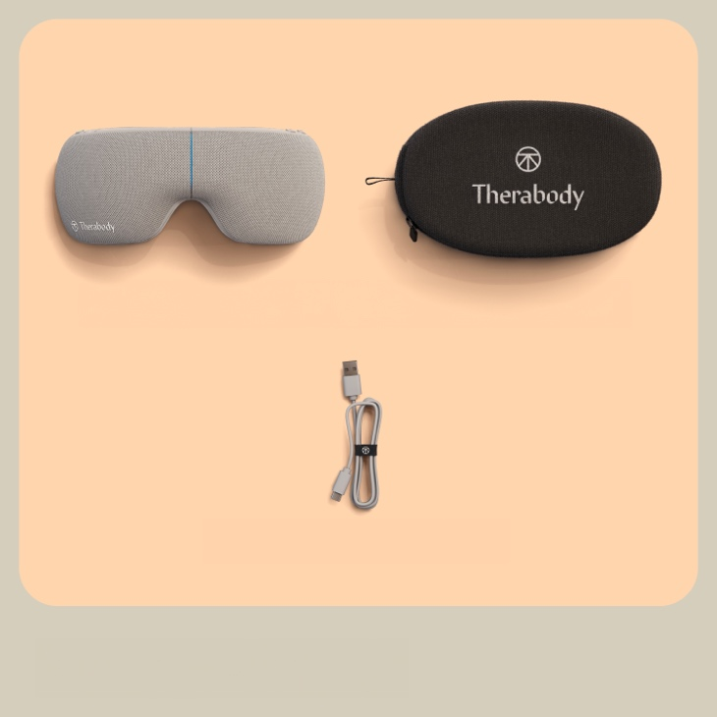

What is included in the price
- SmartGoggles device
- Soft protective case
- USB-A to USB-C charging cable

Video: https://youtu.be/hrU8F8KFkhE?si=ckeQBHVFYNiS2grN

